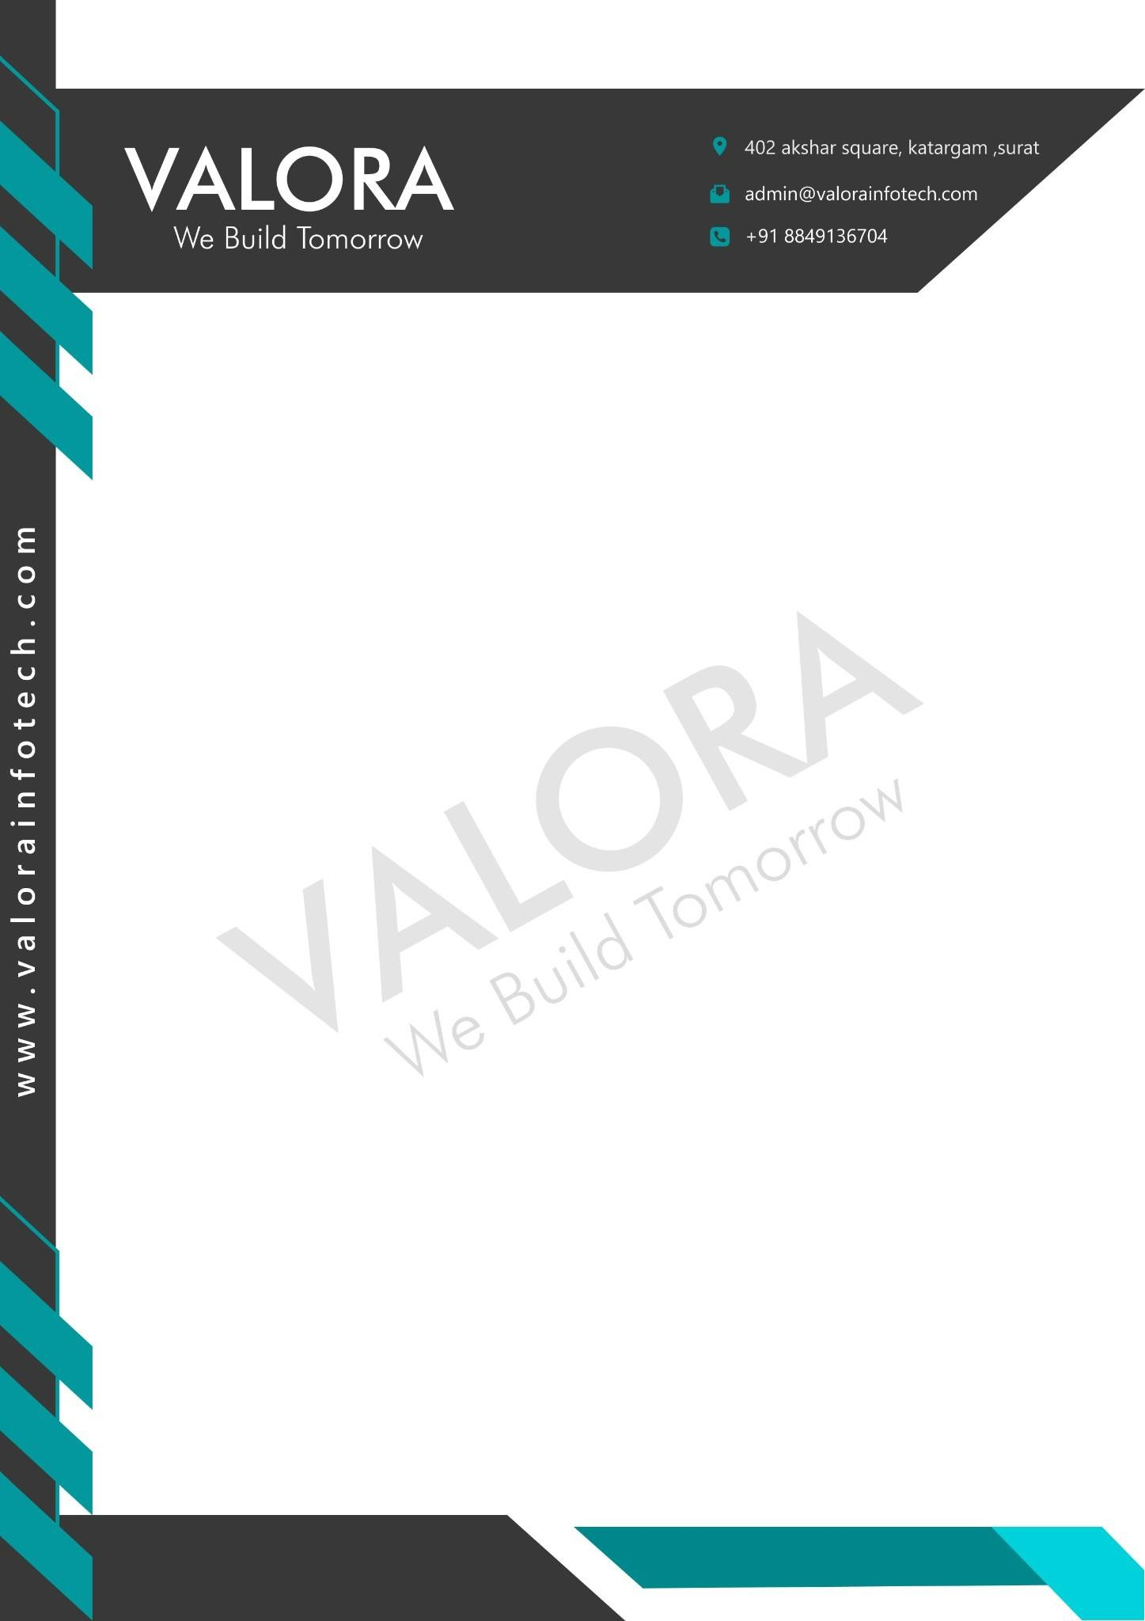

Date : 11/05/2026

Dear Meet Bhingradiya,

This has reference to your application and the subsequent interviews you have had with us. We are pleased to make you an offer for the position of Intern as a Unity Game Developer in Development at our company Valora Infotech. You will be given a Letter of Appointment on joining.

Your designation will be Intern as a Full Stack Web Developer in Development. Your internship period will start from 12st May 2026.

Please sign and return to us the duplicate of this letter as a token of your acceptance of the above terms and conditions.

We look forward to you joining our team and hope it is the beginning of a mutually fulfilling association.

Valora Infotech

Nayan Lodaliya(CEO)

